Stress and Mental Distress Among Students:
Gender Patterns, Social Drivers, and Service-Side Action Points
1. Introduction
Student stress and mental distress are increasingly recognised as major concerns in adolescent health. This report investigates stress-related distress signals among students—specifically loneliness and worry severe enough to disrupt sleep—and examines how these outcomes vary by gender and age. Beyond describing prevalence, the report evaluates likely drivers of distress (social vs physical exposures) and connects findings to an actionable service context in Singapore through the distribution of student care centre quality and enrolment.
2. Data Sources
2.1 Malaysia adolescent survey (2012) (WHO microdata)
A Malaysia adolescent survey dataset (WHO microdata) is used to establish population-level patterns in distress indicators and explore associations between exposures and distress. Variables used include:
- frequency of feeling lonely (high loneliness defined as “most/always”),
- frequency of being so worried that sleep is disrupted (high worry-sleep defined as “most/always”), and
- a composite indicator of high distress (either).
The dataset also includes candidate exposure variables reflecting physical behaviour (e.g., physical activity frequency) and social environment/support (e.g., bullying, parent understanding, school support, close friends).
2.2 Singapore Student Care Centres GeoJSON
A Singapore Student Care Centres GeoJSON dataset (n = 347 centres) is used to translate findings into service-side recommendations. Key fields include:
- AUDIT_STATUS (audit grade as a quality proxy: A/B/C/D),
- ENROLMENT (reach proxy),
- BUSINESS_PROFILE (e.g., commercial vs SSA), and
- fee and contact fields (not central to the main action plot).

3. The landscape of distress: gender and age patterns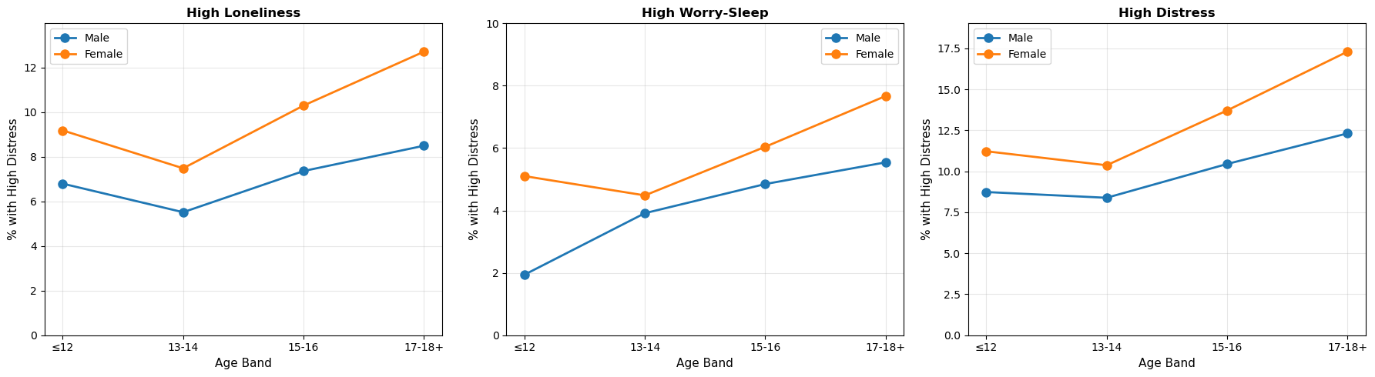
- Across all age bands, girls have higher rates of high distress than boys, and distress generally increases with age, especially into older teenage years.
- For both genders, distress becomes more pronounced at older ages (15–16, 17–18+).
- The highest levels appear in older teenage girls, suggesting that late adolescence is a critical period.
4. Potential drivers: social stressors explain more than physical activity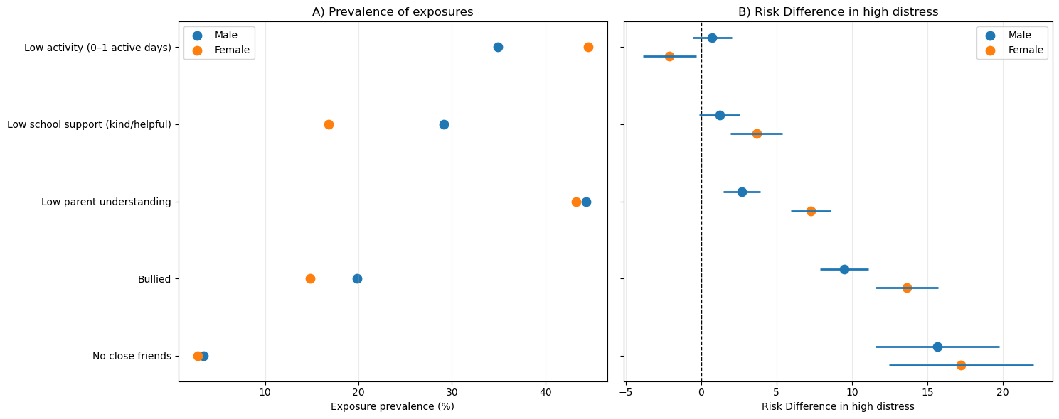
- Exposure prevalence
- The left panel shows how common each “risk factor exposure” is in boys and girls
- Some exposures are higher in girls (low physical activity) while some are higher in boys (bullying)
- Exposure differences alone don’t fully explain why girls have higher distress
- Risk difference in high distress
- The right panel shows how much distress increases in exposed versus unexposed students, separately by gender
- The largest increases in distress appear for social factors such as no close friends and being bullied, and these effects often look larger for girls
- Even when girls have higher prevalence of low activity, the risk difference iss small compared to social factors
- Translating evidence into action: targeting student care quality at scale
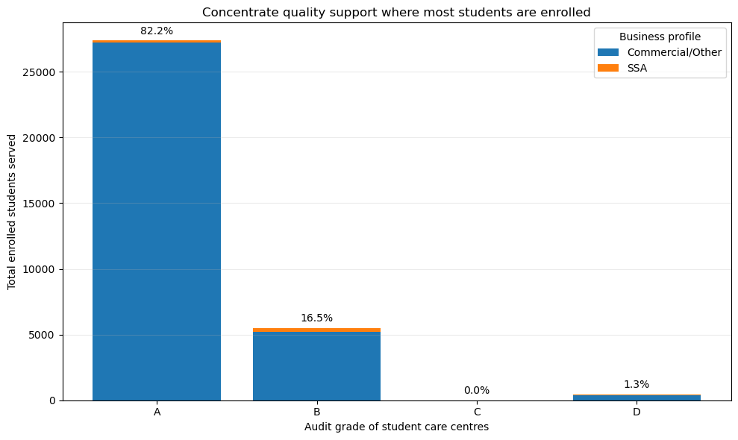
- Approximately 82.2% of enrolled students are served by Grade A centres.
- Approximately 16.5% are served by Grade B centres.
- The graph motivates 2 improvement strategies in improving centre care quality:
  - Grade B centres serve a meaningful fraction of students (1/6). Raising their quality toward A-grade standards would deliver improvement at scale.
  - Although grade D serves fewer students, it represents the lowest quality tier; targeted monitoring and corrective action can protect students in the highest-risk settings
- Limitations
- The Malaysia dataset provides correlational evidence and may not fully generalise to Singapore students.
- “High distress” is based on survey frequency categories and represents a proxy rather than a clinical diagnosis.
- The student care dataset reflects service quality and reach, not direct mental health outcomes; the link to distress is conceptual (via social support mechanisms) rather than directly measured.
- Conclusion
Student stress-related distress shows a clear gender and age gradient, with older teenage girls most affected. The strongest correlates of distress are social rather than physical factors. Translating these insights into action, Singapore can focus quality improvement resources on student care centres serving large numbers of students but not achieving top audit grades, while maintaining safeguarding interventions for the lowest-grade centres.

